Determining the Captain of the Black Joke

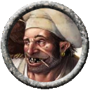
Ambrose comes on deck at a time when all the crew is present. He says in a loud voice: "The matter of captain must be resolved now. I have been a pirate along these isles longer than any of you have been alive. Picking a pirate captain is always done by votes. I have had several nominations already, Medeor, Ragnos, Wingnut, Drek'Thar and Concobjar Shortstone. Is there anyone else that has a nomination?'
Sandara Quinn speaks up: "Not to mention that when or if Harrington discovers his prize has been stolen, he will hunt us all down and kill us to the man. Whoever we pick for captain needs to be tough enough and cunning enough to outwit Harrington."
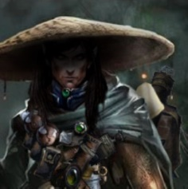
No doubt.
Though the man that mutinied against Harrington is lying before us.
Lightly kicks plugs corpse.
Harrington is welcome to extract further justice upon what's left of him.
Technically we have taken Harrington's side by winning back the ship. And now find ourselves aground from a storm, no fault of our own. We have broke no code nor warrant dishonor or shame.
The real question is if we meet Harrington again, do we parley or fight. Or does he?
And what type of captain do we want if Harrington does seek parley?
Though agreed. The waters will test our mettle in many ways. Not all will involve swinging a big sword.

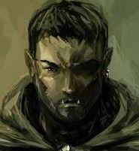
Ragnos gives Cog a meaningful sidelong glance, who gives an encouraging grin and nod in return. He then steps forward – Owlbear shadowing him like a faithful hound - draws his sword, stabs it into the deck, rests his arms on the guard and addresses the crew.

“Votes and nominations be damned to The Deep where they belong! We’ve all been chafing under the heel of those weak-kneed catamites, Harrigan and Plugg, with their laced rum and chasing of merchants that barely have provisions in their holds, let alone plunder for one and all!”

He raises one fist in the air “What we need now is a leader that believes in STRENGTH! POWER!! RICHES BEYOND THE IMAGINING!!! One that has the VISION to bring back TERROR to the shipping lines while we ravage their trade and send their leaky pinnaces to The Undergrave where they belong!”

He circles around, pointing at every member of the crew “Many of you here are not here through your own want or making; and have been thinking of late there’s no future except for the slow death of the undersea or the quick death of a deckside battle. If you’re with ME as Captain, I’ll take you on voyages that will have you see sights beyond your reckoning! Bring you plunder enough to ensure retirement before your bones feel the windlash of time! And with all that… tales of your own personal glory that will still be told when your grandchildren have grandchildren!”

“I now declare myself as the only worthy to be Captain of this here ship” He gives the pommel of his embedded blade an affectionate pat, full of deadly meaning “The deck is now open for… opposing viewpoints.”

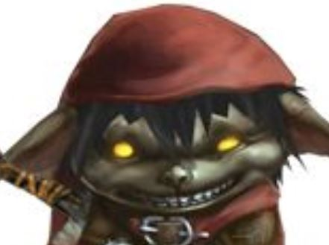
Wingnut speaks up in response to Ragnos.

"Big Boy has strength for sure. Can smash heads and swing a sword but does he have anything else? A captain needs brains too".

He gives Ragnos a toothy grin

"Cunning beats strength every time! And the cunning beat the strong every time"

He looks about at the crew

"Wingnut would make a good cunning captain. But I know a few people who could be good as well"

He flips a small dagger in his hand.

"Wingnut says we follow tradition. But vote for smarts as well as strengths"

While our little goblin speaks plainly, he speaks in wisdom.

A ship is her crew. Jointly we are her beams, her ropes and her masts. Without us she has no breath of her own.
However at her heart is the captain. Her heart is what will drive her. Define her.

Our question then.

What heart should beat within her?

A Drek'Thar ship would be ferocious no doubt. Strong and brazen with no fear or restraint.
But will it have tact when words are needed? Will it have subtlety when guile is called for?

A Ragnos ship will be spirited with passion and drive. It will seek her own justice to her last breath is spent.
But should she dive into waters unknown only to find herself out of depth and flailing herself?

A Concobjar ship would be heartfelt and kind. Her loyalty would be strong and her head held tall.
But her stature would always be seen as unfairly short. Always mocked. Always preyed upon. Never taken seriously.

A Wingnut ship would be slippery and wily. Slipping into the shadows causing mischief and mayhem at every turn.
But would her hands ever know her heart? And her head will always be turned about with tasty, distracting morsels that others may find distasteful.

A Medeor ship? I'm not sure I can justly speak to what manner of ship is that.
There is a strength and wisdom behind those eyes so she may well be the finest ship in the seas. But thus far, that heart, no doubt pure and passionate, has seemed aloof.
I look forward to seeing more of the Medeor heart in my coming days. Though my friends a decision is upon us now.

A Jimmy ship perhaps?
A ship that thinks a far off. A ship that picks its battles with tact and precision. A ship that shares its vision with its head and its hands.
A ship that knows when to fight, and knows when to be still. A ship with a tongue to speak and ears to listen.
Her sword may not be the strongest, but it is sharp. Her arrow may not always hit her mark, but her vision is true.

A Thallan ship?
No. No, but thank you my dear sailors. I well know you do not need a Thallan ship. I may well be its head in delicate matters, but my heart is elsewhere.
I will serve our ship, indeed our crew, and our newly, thoughtfully appointed captain with my all. As I know of us all.

But if we are to survive, no, thrive, we will surely need to share the same blood pumped by her new heart.
What blood is to run through your veins?
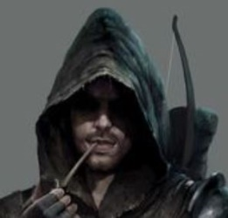
Jimmy snorts at the suggestion of him as captain.

I like your thinking Thallan, but I fear I am ill-suited to be captain of this vessel. We need strength to keep these swabs in line, but I think we have that between me, ragnos and drek.

For my thinking there are 2 options to lead this vessel Drek or Wingnut. Do we favour strength or cunning?

Don’t look at me like that Ragnos – spirited though you may be, I recognise a darkness in you that resonates with my own and we would best serve as officers, lest our darkness overwhelm this vessel, yet our strength will keep this lady afloat.

Jimmy looks to the horizon wistfully and whispers ‘perhaps one day, when I am again made whole, this may change’

We need to decide this vote for the long term. Once our votes are cast let us all rally behind our leader.
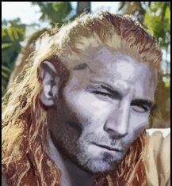
Medeor leaning back on one of the few bit of stable railing looks about the deck.

Hearing Ambrose suggest him cracks up laughing “Ahh oh our sodden scullery fiend, thankyou for the thought but I ain’t no captain, just a servant and warrior of Gozreh and just ‘nother that sails on her seas.”
Looks to Ragnos “So ye be looking to repeat Harrington’s captaincy then? We all know how that’s turned out. Put that damn pig sticker away you lummox, there’s more holes in the damn hull then on offer at a whore house already”

Staring to the clouds on the far horizon “I’ll follow a rightful Captain, headlong into Gozreh’s own fury if needs be, Captains rules are just that, but there is a difference between punishing your crew and abusing them.”

Eyeing all the people on deck “Jimmy rules himself out, as do I. Out toothy friend there could probably sniff out a gold fleck on the wind in hurricane a mile off, his skills shouldn’t be confined to the Captain Quarters. I think I’ll follows Jimmy’s lead on this one, Drek’s also a bit of lump but no so hard headed a to not listen”

Jimmy, I did not realize your heart's heaviness, though I see it more clearly now. I honor one whom sheds open ambition for the shadowy path to inner truth. I too am on that path.

There is no doubt a Drek or Wingnut 'heart' would be mighty in its own ways.
I offer however we need to ask more of these heros than they have shown thus. Can they give more? I believe they well may. May I suggest now is their chance to offer how?

Would a Drek-heart be capable of subtly, restraint or dare I say compassion? Would it stay a blade when words are sharper? How so?

Would a Wingnut-heart stand tall (ahem) and resolute in the face of distraction? Would it leave the shadows to lead in plain view? How so?

Both would be worthy adversaries that I am sure. And I would be willing to follow either as indeed all of us are only yet alive due to their gallant deeds.
But where would they lead us....to a rich maturation or to a valiant, triumphant end?

I, don’t disagree with that actually. You make some good points Thallan.

To be perfectly honest if we survive this storm we are going to need all remaining hands to sail this vessel.
Perhaps instead of threatening bloodshed (Jimmy glances wryly at Ragnos) we can each hear what the proposed captains plan to offer and how they plan to achieve it? Based on this we can then cast our votes. After all, a good captain needs to be able to communicate AND keep his crew in line which takes more than just a strong arm or a slippery nature.

Once the captain is appointed officer selections will be just as important to keep the crew in line and in that I am ready to serve diligently.

Jimmy then moves over to Thallan and quietly starts chatting to him, whilst keeping a keen eye on how things unfold on the main deck.

*Drek’Thar steps forward*
“Ragnos. You are indeed a formidable warrior, but we will be going with tradition on this one. You may recall what happened last time this bunch was placed under command by means of decree.”
*glances deliberately at the corpses of Plug and Scourge*
“The funniest thing is if they had just asked instead of kidnapping they could have had an ally in me. Pirating is in my blood. I’d have joined willingly.
*looking back at Ragnos*
“The seas are in MY blood, and if it’s opposing viewpoints to the traditions of the waves you’re looking for, I’d be happy to oblige.”
*fists briefly clench*
“As for the question of strength versus cunning. I would put forward that cunning can easily be counselled, but no one can wield your sword for you. Is not strength with the wisdom and willingness to listen the better compromise? Besides, *grinning at Wingnut* if you every got too annoyed with me you can just steal all my stuff.
Sandara, you raised the question of Harrington and his ready vengeance for this betrayal. Whether ours or our predecessors *glancing at Thallan* I am confident the consequences will be the same. I am no fool, nor do I have a death wish. I have no desire to cross blades with that man, and I’m sure there are many free captains or even Pirate Lords to whom we could ally if need be. A man like Harrington no doubt has more enemies than just us. However, should it become unavoidable I don’t know about the rest of you, but I intend to go down swinging.
Jimmy, you call for arguments? Very well. I would offer 3 differences to the rule of either Harrington or Plug that you could expect under my lead. Firstly, drinking and games will be allowed again and even encouraged, but not mandatory. *again glances at Thallan*
Secondly, no more press-gangs, and any who are here against their desires and wish to leave will be able at the next convenient port. Kidnap victims make bad sailors, and I think we all remember how I personally felt about that. I’m sure Scourge would remember if he were still able.
Lastly, no more keelhauling. The risk of death is too great. If punishments are to be metered out I won’t have anyone getting out of them by dying. Death is a release, not a punishment. I know for myself, on that day, I will join with Besmara’s mighty fleet and pillage the very heavens to glory and riches beyond any in this mortal realm! Not much of a punishment.
In the meantime, what say we cause a bit of havoc, eh? They will know us. They will fear us! Children will tell stories of our deeds in the dark of night! We will live as kings on the seas, with wealth greater than the Hurricane King!! JOIN WITH ME AND TOGETHER WE WILL BECOME LEGEND!!
Concobjar Shortstone stands up and joins Ragnos and Drek'Thar on the deck. "Don't count me out either! I have personally killed a thousand crabs, even saved Ragnos from the throes of the storm sea and many more things besides." He holds up his thin cane. "A vote for me is a vote for cunning, a vote for fun and festivity, and a vote for stabbing!" he mimes stabbing a crab on the deck with his cane.
Ambrose Kroop steps out among the three, with a charred wooden box with a thin slot in the top. "Well we have all heard the rhetoric and the bluster." he looks pointedly at Ragnos and Drek'Thar "If you need to bash each other’s skulls in first, how about we get that over and done with, hmm? But I've never served on a ship that didn't vote for its captain, and if it’s going to be that I'd rather sit and twiddle my moose on this here island." Ambrose starts stripping pieces of cloth and handing them to people about the deck, along with pieces of charcoal. "Just the first letter of the captain's name will do, then stuff it into this here box. And no funny business, you get one vote only."

